WEST POINT CITY
NOTICE OF PUBLIC HEARING

Notice is hereby given that on January 9, 2024, the West Point City Planning Commission will hold a public hearing at 3200 West 300 North, West Point City, UT, beginning at 7:00 PM. The public hearing will be for a Zoning Amendment regarding property located at approximately 5750 West 2425 North. The request made by H.L Parker Farms LLC is to change the zoning on 35 acres of land from A-5 (Agricultural) to R-1 (Residential/maximum of 2.2 units per acre). The concept plan shows 78 single family lots at approximately 2.2 units per acre.

All interested parties are encouraged to attend and express their opinion on the matter. To review documentation related to the above hearing, contact West Point City Hall at 801-776-0970. If you need special accommodations to participate in the meeting, please call West Point City at least twenty-four (24) hours prior to the meeting at 801-776-0970.
Rezone
5750 West 2425 North

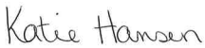
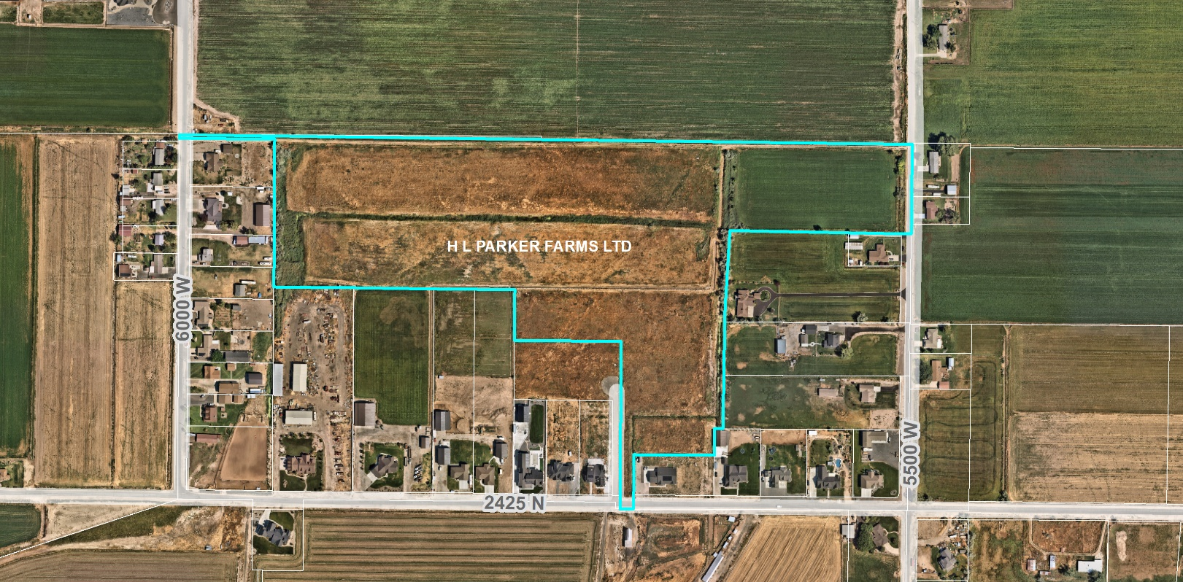
Posted this 30th day of December, 2024
Katie Hansen, Deputy City Recorder

